WASPA Spring Wellness Pre-Conference
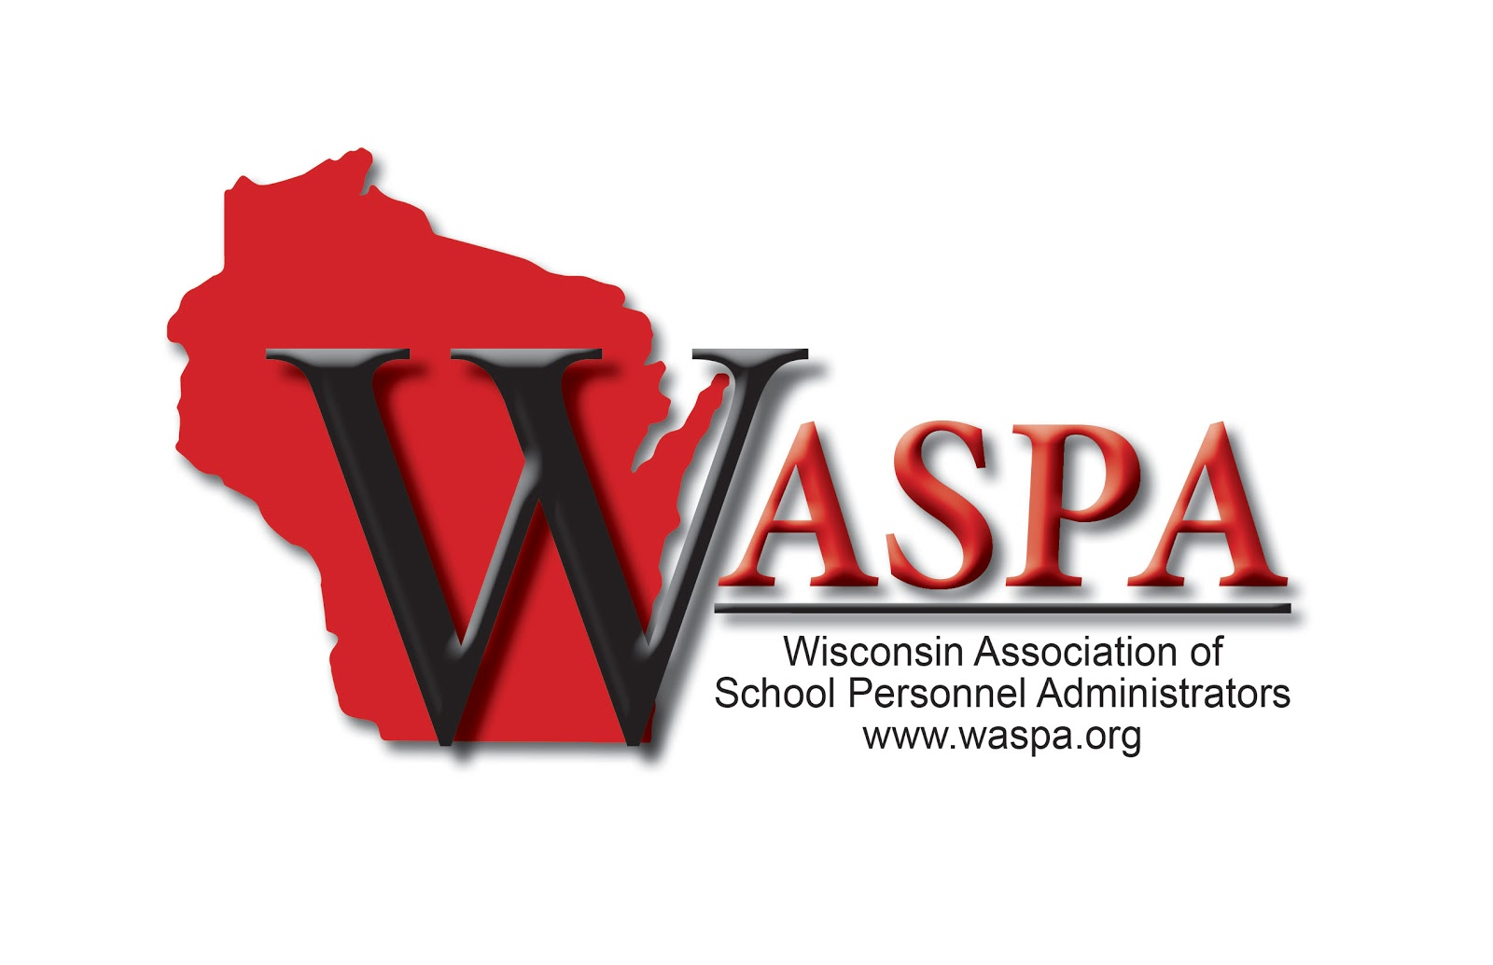

Wilderness Resort – Wisconsin Dells

April 24, 2019

Employee Wellness Benefits 1:00 – 4:00 PM
Join the Chippewa Falls, Elmbrook, Middleton Cross Plains, and New Berlin School Districts, along with MMA in learning more about best practices in Employee Wellness Benefits. Help your employees get healthy and decrease your medical spend!

1:00 Emerging Trends in Wellness Benefits
1:45 Tying Metrics/Analytics to Wellness
2:30 Comfort Break
2:45 Wellness Panel Q&A
3:15 Coordinating Your District’s Plan
4:15 Wrap Up/Q&A

2019
July 9-10 Legal Seminar for Experienced HR
Stone Harbor Resort, Sturgeon Bay

Summer 2019 New to HR One-day Seminar TBD

October 8-11 AASPA Conference
New Orleans, LA

November 12-13 Administrative Support Seminar
Osthoff Resort, Elkhart Lake

November 13 Director & HR Support
Osthoff Resort, Elkhart Lake
New(er) to HR Pre-Conference

November 14-15 Director’s Conference
Osthoff Resort, Elkhart Lake

December 4-5 WASPA/WASBO Joint Conference
Madison, WI

